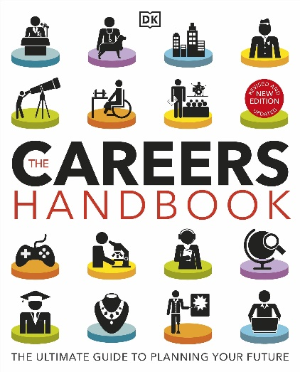

TITLE: The Careers Handbook: The ultimate guide to planning your future.
Authors: DK
Publisher: DK Children
Age: KS3/4
Also available as an eBook

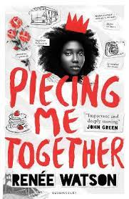
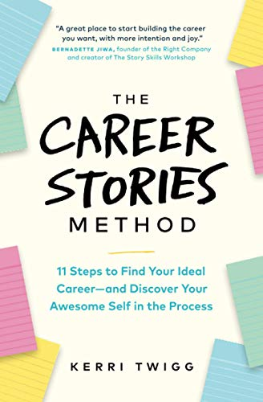
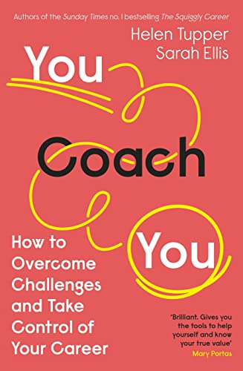

TITLE: You Coach You- How to Overcome Challenges and Take Control of Your Career
Authors: Helen Tupper/ Sarah Ellis
Publisher: Penguin Business
Age: KS3/4
Also available as an eBook

TITLE: The Career Stories Method: 11 Steps to Find Your Ideal Career—and Discover Your Awesome Self in the Process
Authors: Kerri Twig
Publisher: Page Two Books
Age: KS3/4
Also available as an eBook

TITLE: Piecing Me Together
Authors: Renée Watson
Publisher: Bloomsbury Children’s Books
Age: KS3/4
Also available as an eBook

